**CHAPTER 3**

**SYSTEM DESCRIPTION AND ARCHITECTURE**

**3.1. SYSTEM OVERVIEW AND REQUIREMENTS**

After doing some research and going through different articles, we started to work on a system that can help in the current traffic and parking issue our city faces. We started out with a grand idea of finding a smart way to assist drivers to park their cars with consideration of the implementation and cost to account. From our research we found out a lot of ways the problem can be tackled; we found some companies that made a business out of implementing a smart parking system.

Some of the implementations we have discovered are crafted well and precisely they are what we call revolutionary ideas that take a huge leap to the future. Those ideas, although look appealing on paper, they will cost a lot which does not go with the current financial status of our country. So, we set out to find a financial sound and implementation wise satisfying system.

Our system mainly depends on four factors:

* Space
* Information
* The right Individual
* Real time

We are working towards finding the best/optimal way to connect the above factors.

The main objective of the project is Delivering the right information to the right individual about space at the right time.

In our project the working definition of the factors are:

* **Space**: parking area/slot/building
* **Information**: availability or occupancy
* **Individual**: driver or concerned personnel/group
* **Time**: real time

We worked on introducing technology to the working system.

What technology?

* **IoT**: The Internet of Things is essentially a system of machines or objects outfitted with data collecting technologies so that those objects can communicate with one another.

IoT is all about the Network, Devices and Data.

We designed and implemented a system that gathers information about availability of a parking space from its sensors, which will report to a lower level controller; which in turn will send to a local controller which is responsible to send the information to the server. The information gathered by the sensors need to be accurate for the information to be accepted so we have also incorporated a way in which parking attendants of parking areas and parking buildings contribute to the system, they will be able to send information about the vehicles that entered the premises.

Based on the information from the sensors and the parking attendant data the server will organized the data into a format that is suitable for drivers so they can access it from their mobile devices to get the information about the availability of a parking slot in a certain area. Our system is designed and implemented to be a right hand for the drivers of our city by giving them options of reservation and GPS based map guidance that comes pretty handy when one doesn’t know where to find parking.

**3.2. PROJECT PLAN AND TIMELINE**

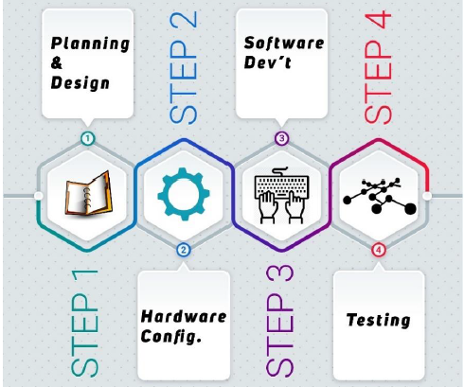

Figure 3: Project Steps

We started out with sub dividing the project as seen in (figure 3). The different modules of the project are sub divided on each stage to further components.

* **Planning and Design Stage**: we did a lot of tinkering by experimenting on different ideas while maintaining a clear milestone and other objectives of the project. After having the general understanding of the project, we moved to analysing our system from a working point of view. We were taking into account implementation, considering feasibility to the basic component level.
* **Hardware Configuration stage**: we configured sensors and controllers which is our base line for the overall project. We worked on object(vehicle) detection and communication among the controllers, we tested different communication modules and picked the one with the least cost and better performance the meet our standards that were set at the beginning. We also configured the controllers to send data gathered from sensors to the server.
* **Software Development**: we worked on the client side and server configuration. User end applications with simple and easy to use interface and design was implemented. Information that is gathered by sensors and sent by the microcontroller to the server for processing. We focused on the development of android application and admin dashboard. The app development had two components which involved a parking attendant and driver as users. The user app accesses data for the most part and using the parking attendant app, the parking attendant feeds data to the server to further strengthen the data collected from the sensors and reduce the margin of error.
* **Testing and Debugging**: we checked each module as individual components and as components of the whole system. We designed tests that were based on the initial requirements of such a system that is feasible for the metropolitan cities.

**3.3. WORKING PRINCIPLE**

Internet of Things (IoT) is a combination of interrelated devices which includes computing devices, microcontrollers, different types of sensors and machines which are interconnected with each other over the internet to perform a designated task with no human to computer interaction.

IoT is a technology that connects different devices to the internet and communicates with the user where the user can remotely control and monitor the device or just use the information fed to the system by the sensors and the use of IoT has exponentially increased in the recent years due to the availability of different technologies which will make it easy to connect to the internet.

IoT is integrated with four different characteristics which make it perform the task it is designated to.

Sensors and devices are devices which may have special properties or perform simple task to get information from the environment such as in this scenario to detect the presence of a vehicles with the help of sensors. The task of the devices mainly is to grab information from the environment.

Connectivity, this is the most important part of IoT which is to connect the sensors or the devices to a cloud, a platform that can be accessed through the internet. So, we should make sure that the internet connectivity is given. To achieve this, different methods are used such as using GSM (which is the most common form) or by Wi-Fi or connecting directly via Ethernet which will route to the internet.

Data Processing, once the data is transmitted over the internet to the cloud/server then there have to be a data process which would be performed and displayed to the user. These processes may involve displaying the temperature or the availability of a vehicle in a slot (our project) and much more.

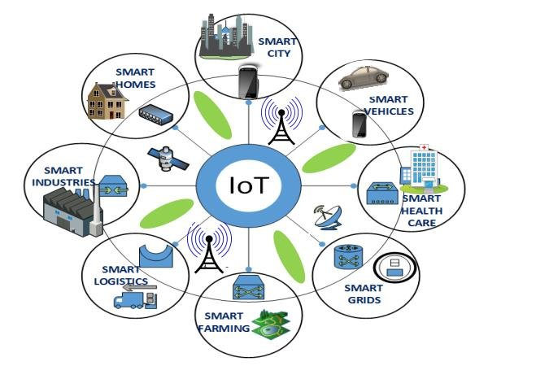

Figure 4: Internet of Things

User Interface, this is the platform in which the data could be communicated with the user. And also, the platform in which the user can remotely send instructions to devices to perform particular tasks such to activate or deactivate, on or off etc. The users can connect to the IoT application via a mobile or desktop application but the most commonly used platforms as there is no need to design specific native apps and desktop apps for different vendors but just implement the user communication module in the web interface as its compatible to all devices.

Our project will be following the general requirements of an IoT system working towards developing and deploying a stable and responsive system. The project will start out with the sensors found in parking areas and slots, which will be wired to Arduino, which is connected to the NodeMCU ESP8266, which sends data it gets from the Arduino collected from the different sensors. The data sent is stored in the server and updating in real time for both the admin and the users that are interested in the system. The different components of the project are governed by the general rules of IoT and specific rules of the device in use.